
UK ROAD PATCH

FRANCHISE OPPORTUNITY PACK

A specialist mobile highways business for a defined local territory
“Repairs that last five years, not five weeks.”
80  TOTAL TERRITORIES | 70  UNITED KINGDOM | 10  REPUBLIC OF IRELAND

Highway Safety Systems UK Limited
Sole UK and Republic of Ireland Strategic Partner importer and distributor of American Road Patch

The opportunity Summary
UK Road Patch is developing a controlled network of 80 franchise territories: 70 across the United Kingdom and 10 across the Republic of Ireland. Each franchisee will operate a branded, mobile installation business supported by specialist equipment, training, technical procedures and central commercial support.
CORE CUSTOMER PROPOSITION
The existing highway contractor completes the pothole repair. The local UK Road Patch franchisee in attendance or scheduled to attend later, installs American Road Patch over the completed repair, following the approved UK procedure.

What this pack contains
- The product, market need and franchise business model
- Local-authority and appointed-contractor operating model
- Technical methodology, training, quality control and warranty
- Vehicle, lifting, propane and ancillary equipment specification
- Franchise support, customer markets and candidate profile
- The complete 80-territory schedule: UKRP-01 to UKRP-80
- Territory allocation, exclusivity, reserved rights and implementation principles

WARRANTY CLARIFICATION
The contractual customer repair warranty is TWO YEARS, subject to the written warranty terms and correct installation. The five-year strapline is marketing language only and must never be represented as a five-year warranty.

1. A different approach to pothole durability
Highway authorities and asset owners face the recurring cost, disruption and reputational impact of failed pothole repairs. Traffic loading, braking, acceleration, turning forces, water ingress and edge deterioration can undermine conventional repairs and lead to repeat intervention.
American Road Patch is a specialist geosynthetic road-repair treatment installed over a completed repair. The UK Road Patch proposition is designed to protect that repair, support a durable seal at the repair area and reduce the likelihood of avoidable repeat work.
1  REPAIR  The authority's appointed contractor completes the underlying pothole repair. | 2  ATTEND  The local UK Road Patch franchisee attends the completed repair simultaneously with stage 1 or later. | 3  PROTECT  American Road Patch is installed using the approved UK methodology. | 4  RECORD  Quality-control and warranty records/photographs are completed.

The market message
DON'T JUST REPAIR THE POTHOLE. PROTECT THE REPAIR.
The franchise does not depend on displacing an authority's incumbent pothole-repair contractor. It adds a trained specialist installation service to the existing maintenance supply chain.

2. Product credibility and UK development
- American Road Patch is supplied in the United Kingdom and Republic of Ireland through Highway Safety Systems UK Limited.
- British Board of Agrément Certificate 25/H7403 was achieved in May 2025. Any technical claim must remain within the current certificate scope and continuing-validity requirements.
- UK trials have included Cheshire East Council and work involving M Group and Ringway; all trials reported to UK Road Patch have been successful.
- The UK installation method incorporates controlled infrared heating of the road surface to achieve uniform heat saturation being a prerequisite for ARP bonding.

EVIDENCE-LED SELLING
Franchisees must use approved technical literature, current certification, documented trial evidence and authorised warranty wording. Unsupported performance, lifespan or certification claims are not permitted.

3. The franchisee's role
The franchisee becomes the local UK Road Patch representative and trained installer within its allocated exclusive commercial territory. Its role combines relationship development, site attendance, compliant installation and quality documentation.
1. Develop relationships with local authorities, highway teams and procurement contacts within the territory.
2. Engage with the authority's appointed Tier 1, Tier 2 and regional highway contractors.
3. Arrange demonstrations, trials and approved introductions using central materials.
4. Attend after the underlying pothole repair has been completed by the appointed contractor.
5. Install American Road Patch using the prescribed UK methodology and approved equipment.
6. Complete installation, photographic, temperature, batch and customer records.
7. Support the two-year repair warranty and respond to inspections or claims under the written process.
8. Build repeat local-authority, contractor, commercial and private-sector work.

Customer routes
Customer group | Opportunity
Local authorities | Support highway maintenance programmes and completed pothole repairs.
Appointed contractors | Provide a specialist finishing treatment within the existing delivery chain.
Tier 1 and Tier 2 contractors | Integrate into regional frameworks, pilots and subcontract supply chains.
Commercial and industrial | Car parks, retail parks, distribution centres, estates and hardstandings.
Private sector | Private roads, managed estates and other approved asphalt applications.

4. Your protected commercial territory
80  TOTAL TERRITORIES | 70  UNITED KINGDOM | 10  REPUBLIC OF IRELAND

Franchisee Exclusive Territories are designed as commercial operating areas, not equal areas of land. Population, road mileage, traffic, authority procurement, contractor coverage, customer density and travel time inform final classification and performance targets.
The schedule groups approximately three local authorities where that produces a coherent operating area. It does not impose a rigid three-authority rule: dense urban authorities may stand alone, while lower-density rural authorities may be combined in larger geographic groups to balance workload and travel time.
- 48 territories in England outside London
- 8 dedicated London territories covering all 32 boroughs and the City of London
- 5 territories in Scotland
- 5 territories in Wales
- 4 territories in Northern Ireland
- 10 territories covering all 31 Republic of Ireland local-authority areas

TERRITORY STATUS
Each territory will be recorded as Available, Reserved or Sold. Geographic exclusivity will arise only under signed documentation and will remain conditional on performance, training, quality, reporting and payment standards.

5. The complete mobile installation operation
The franchise vehicle is intended to present a consistent national image and provide a safe, practical mobile base for the product, infrared heater, propane system, tools, PPE and site records.
Component | Proposed standard | Purpose / requirement
Vehicle | Grey Volkswagen Transporter | Professionally sign-written in approved UK Road Patch branding. A grey Ford Transit may be approved as an alternative.
Vehicle conversion | Specialist internal fit-out | Secure racking, storage, work lighting and load restraint for materials and equipment.
Propane carriage | Purpose-designed cylinder arrangement | Ventilated, secured and segregated transport configuration with suitable signage and emergency equipment, subject to applicable law and final risk assessment.
Vehicle-mounted lift | Penny vehicle-mounted lift, approximately 200 kg capacity | Assists safe loading and unloading of the RynoWorx R4 and other heavy equipment. Exact model and installation require converter approval.
Primary heater | RynoWorx R4 infrared asphalt heater | Propane-powered infrared heating system used in the approved UK installation methodology.
Ancillary heating | Mobile propane torch for tarmac | Used only where prescribed for preparation or finishing; it does not replace the R4 primary heater.
Compacting Equipment | Plate Compactor | Petrol of Electric powered 60KG
General Tools | Milwaukee 2267 – 40 Infrared Non-contact thermometers  Multi tool cutter for AARP or box knife were permitted with correct non cut gloves. | To ensure the temperature of the tarmac surface is maintained at 100C to 120C throughout installation.

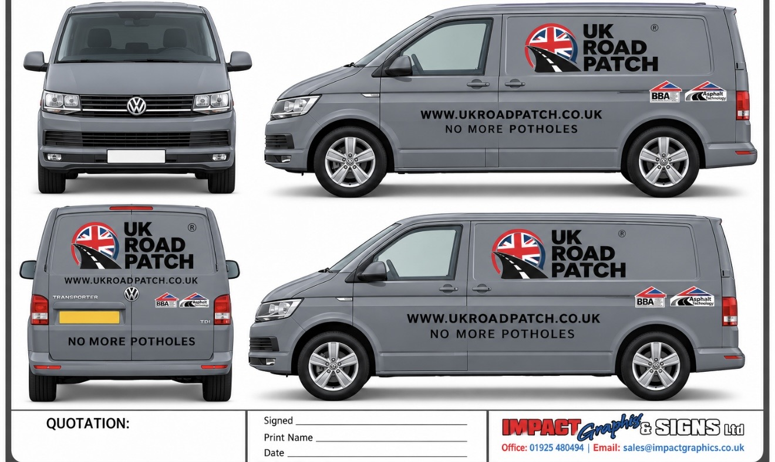

Ancillary tool and safety schedule
- Asphalt rakes, shovels; scrapers, hand tampers and approved compaction equipment.
- Stiff brushes, brooms, blowers, cleaning and surface-preparation tools.
- Calibrated surface-temperature monitoring equipment and installation measuring tools.
- Approved propane hoses, regulators, fittings, leak-testing equipment and ignition equipment.
- High-visibility clothing, safety footwear, heat-resistant gloves, eye protection and hearing protection where required.
- Suitable fire extinguishers, first-aid kit, spill/emergency equipment and documented cylinder checks.
- Cones, barriers, signage and temporary traffic-management equipment appropriate to the site and traffic-management plan.
- Secure boxes, racking, load restraints, work lights, charging equipment, consumables and controlled documentation.

6. Training, installation and quality control

TRAINING OUTCOME
Perform compliant road patch repairs using the RynoWorx R4 Infrared Heater or open propane flame (where permitted). The RynoWorx R4 Infrared Heater is the preferred method, which provides the required surface temperature of approximately 95°C to 110 °C to facilitate effective bonding of the American Road Patch material. Infrared heating minimises surface degradation and supports consistent temperature distribution.
- Product identification, storage, batch control and approved applications
- Site assessment, preparation and interface with the underlying repair contractor
- RynoWorx R4 set-up, propane connection, controlled heating and shutdown
- Surface-temperature checks and installation sequencing
- American Road Patch positioning, installation, finishing and inspection
- Propane-cylinder handling, vehicle safety and emergency procedures
- RAMS, PPE, traffic management and public-interface controls
- Installation records, photographs, customer sign-off and warranty registration
Certification of training does not remove the franchisee's responsibility to comply with site-specific RAMS, manufacturer instructions, highway requirements and applicable health-and-safety law.

7. Two-year repair warranty
CONTRACTUAL WARRANTY
Subject to the applicable written warranty terms and full compliance with the approved UK Road Patch installation procedures, UK Road Patch will provide a TWO-YEAR WARRANTY FOR THE REPAIR.
Warranty eligibility requires approved materials and equipment, trained personnel, compliant surface conditions, complete site records and adherence to notification and claims procedures. The definitive coverage, exclusions, remedies, and claims process will be contained in the customer warranty terms.

Marketing language
The phrase “Repairs that last five years, not five weeks” expresses the intended durability proposition. It is not a contractual promise of a five-year life and must never be described as a five-year warranty. The contractual repair warranty is two years.

8. What UK Road Patch provides
Franchise platform | Support available, subject to the final franchise agreement
Brand | UK Road Patch identity, approved messaging, livery and marketing materials.
Territory | A defined Exclusive UKRP commercial territory with conditional exclusivity.
Product | Supply of American Road Patch through the authorised UK operation.
Training | Technical, operational, safety, quality and commercial training.
Operating system | Approved installation procedures, RAMS framework and records.
Business development | Materials for authorities, contractors and customer demonstrations.
Technical support | Central assistance on applications, standards, equipment and quality.
Warranty system | A controlled process supporting the two-year repair warranty.

9. Who we are looking for
Suitable candidates shall be established preferably, but not essential, with a background in highways, civil engineering, groundworks, traffic-management or construction businesses, as well as commercially capable owner-operators with strong regional relationships.
- Ability to develop local-authority and contractor relationships
- Commitment to technical training and controlled operating standards
- Capacity to invest in the approved vehicle, conversion, equipment and working capital
- Strong safety, quality, record-keeping and customer-service culture
- Willingness to meet agreed territory development and minimum-performance obligations
- Commitment to an 8 year Franchise Agreement with UKRP (renewable).

10. Next steps
1. Register interest and identify your preferred UKRP territory.
2. Reserve your preferred Territory and enter into the UKRP Franchise Reservation Agreement, making payment of the Reservation Fee.
3. Complete initial suitability and financial-capacity discussion.
4. Receive the franchise information, territory data and proposed commercial terms.
5. Undertake due diligence and obtain independent legal, financial and tax advice.
6. Enter the applicable reservation and franchise documentation.
7. Complete training, vehicle conversion, equipment commissioning and launch preparation.

MEET UK ROAD PATCH
APPENDIX A
MASTER SCHEDULE OF 80 FRANCHISE TERRITORIES

UKRP-01 to UKRP-80
70 United Kingdom territories, including eight London territories, and 10 Republic of Ireland territories.

Territory framework
This schedule establishes the proposed 80-territory network.

National allocation
Nation or region | Territories
England outside London | 48
London | 8
Scotland | 5
Wales | 5
Northern Ireland | 4
Republic of Ireland | 10
Total | 80

Exclusivity and reserved work
Territorial exclusivity shall remain conditional on compliance with performance (from year 2), training, quality, reporting and payment obligations.

North West territories
Code | Territory name | Defined coverage for planning purposes
UKRP-01 | Cumbria | Cumberland Council area, including Carlisle, Workington, Whitehaven and the western Lake District; Westmorland and Furness Council area, including Barrow-in-Furness, Kendal, Penrith and the eastern Lake District
UKRP-02 | Lancashire North and Central | Lancaster, Wyre, Fylde and Blackpool council areas; Preston, Chorley, South Ribble and Ribble Valley council areas
UKRP-03 | Lancashire East | Burnley, Pendle, Hyndburn, Rossendale and Blackburn with Darwen council areas
UKRP-04 | Liverpool City Region | Liverpool and Sefton council areas; Wirral, Knowsley and St Helens council areas
UKRP-05 | Manchester Trafford and Salford | Manchester, Trafford and Salford council areas
UKRP-06 | Greater Manchester North and West | Bolton, Bury and Wigan council areas
UKRP-07 | Greater Manchester East and South | Rochdale, Oldham, Tameside and Stockport council areas
UKRP-08 | Cheshire and Warrington | Cheshire East, Cheshire West and Chester, Warrington and Halton council areas

North East territories
Code | Territory name | Defined coverage for planning purposes
UKRP-09 | Northumberland and Newcastle | Northumberland and Newcastle upon Tyne council areas
UKRP-10 | Tyneside | North Tyneside, South Tyneside and Gateshead council areas
UKRP-11 | Sunderland and County Durham | Sunderland and the eastern part of County Durham, with the final boundary to follow named wards in the Franchise Agreement; The western and southern part of County Durham, with the final boundary to follow named wards in the Franchise Agreement
UKRP-12 | Tees Valley | Darlington, Hartlepool, Middlesbrough, Redcar and Cleveland, and Stockton-on-Tees council areas

Yorkshire and Humber territories
Code | Territory name | Defined coverage for planning purposes
UKRP-13 | York and North Yorkshire | City of York and North Yorkshire council areas
UKRP-14 | Leeds | Leeds council area
UKRP-15 | Bradford and Calderdale | Bradford and Calderdale council areas
UKRP-16 | Kirklees and Wakefield | Kirklees and Wakefield council areas
UKRP-17 | South Yorkshire | Sheffield and Rotherham council areas; Barnsley and Doncaster council areas
UKRP-18 | Hull East Riding and Northern Lincolnshire | Kingston upon Hull and East Riding of Yorkshire council areas; North Lincolnshire and North East Lincolnshire council areas

West Midlands territories
Code | Territory name | Defined coverage for planning purposes
UKRP-19 | Birmingham | Birmingham council area
UKRP-20 | Black Country | Dudley and Wolverhampton council areas; Sandwell and Walsall council areas
UKRP-21 | Coventry and Solihull | Coventry and Solihull council areas
UKRP-22 | Warwickshire | Warwickshire County Council area
UKRP-23 | Staffordshire and Stoke on Trent | Stoke-on-Trent, Newcastle-under-Lyme and Staffordshire Moorlands council areas; Stafford, East Staffordshire, Lichfield and Cannock Chase council areas
UKRP-24 | Shropshire and Telford | Shropshire and Telford and Wrekin council areas
UKRP-25 | Worcestershire and Herefordshire | Worcestershire and Herefordshire council areas

East Midlands territories
Code | Territory name | Defined coverage for planning purposes
UKRP-26 | Derby and Derbyshire | Derby, High Peak, Chesterfield, North East Derbyshire and Bolsover council areas; Amber Valley, Derbyshire Dales, Erewash and South Derbyshire council areas
UKRP-27 | Nottingham and Nottinghamshire | Nottingham and Nottinghamshire council areas
UKRP-28 | Leicester Leicestershire and Rutland | Leicester, Leicestershire and Rutland council areas
UKRP-29 | Northamptonshire | West Northamptonshire council area; North Northamptonshire council area
UKRP-30 | Lincolnshire | Lincolnshire County Council area, excluding North Lincolnshire and North East Lincolnshire

East of England territories
Code | Territory name | Defined coverage for planning purposes
UKRP-31 | Cambridgeshire and Peterborough | Cambridge City, South Cambridgeshire and East Cambridgeshire council areas; Peterborough, Fenland and Huntingdonshire council areas
UKRP-32 | Norfolk North and East | Norwich, Broadland, North Norfolk and Great Yarmouth council areas
UKRP-33 | Norfolk South and West | South Norfolk, Breckland and King's Lynn and West Norfolk council areas
UKRP-34 | Suffolk | Suffolk council areas
UKRP-35 | Essex | Braintree, Colchester, Tendring and Uttlesford council areas; Basildon, Brentwood, Castle Point, Chelmsford, Epping Forest, Harlow, Maldon, Rochford, Southend-on-Sea and Thurrock council areas
UKRP-36 | Hertfordshire | Hertfordshire council area, subject to any successor unitary boundaries in force at the relevant time

South West territories
Code | Territory name | Defined coverage for planning purposes
UKRP-37 | Bristol and South Gloucestershire | Bristol and South Gloucestershire council areas
UKRP-38 | Gloucestershire and North Wiltshire | Gloucestershire council area and the northern part of Wiltshire, with the Wiltshire boundary to follow named wards
UKRP-39 | Bath Somerset and South Wiltshire | Bath and North East Somerset, Somerset and the southern part of Wiltshire, with the Wiltshire boundary to follow named wards
UKRP-40 | Dorset and Bournemouth Christchurch and Poole | Dorset and Bournemouth, Christchurch and Poole council areas
UKRP-41 | Devon Plymouth and Torbay | North Devon, Torridge, Mid Devon, East Devon and Exeter council areas; West Devon, South Hams, Teignbridge, Plymouth and Torbay council areas
UKRP-42 | Cornwall and Isles of Scilly | Cornwall and Isles of Scilly council areas

South East territories
Code | Territory name | Defined coverage for planning purposes
UKRP-43 | Oxfordshire Buckinghamshire and Milton Keynes | Oxfordshire council area; Buckinghamshire and Milton Keynes council areas
UKRP-44 | Berkshire | Bracknell Forest, Reading, Slough, West Berkshire, Windsor and Maidenhead, and Wokingham council areas
UKRP-45 | Surrey | Surrey council area, subject to any successor unitary boundaries in force at the relevant time
UKRP-46 | Hampshire and Isle of Wight | Hampshire, Southampton, Portsmouth and Isle of Wight council areas
UKRP-47 | Kent and Medway | Kent and Medway council areas
UKRP-48 | Sussex and Brighton | East Sussex, West Sussex and Brighton and Hove council areas

London territories
Code | Territory name | Defined coverage for planning purposes
UKRP-49 | Central London | City of London, Westminster, Camden, Islington, Kensington and Chelsea, and Hammersmith and Fulham
UKRP-50 | North West London | Brent, Harrow, Hillingdon and Ealing
UKRP-51 | North London | Barnet, Enfield and Haringey
UKRP-52 | North East London | Waltham Forest, Redbridge, Hackney and Havering
UKRP-53 | East London | Newham, Tower Hamlets, Barking and Dagenham, and Greenwich
UKRP-54 | South East London | Bexley, Lewisham, Southwark and Bromley
UKRP-55 | South London | Croydon, Sutton, Merton and Lambeth
UKRP-56 | South West London | Richmond upon Thames, Kingston upon Thames, Wandsworth and Hounslow

Scotland territories
Code | Territory name | Defined coverage for planning purposes
UKRP-57 | Glasgow and West Central Scotland | Glasgow City, East Renfrewshire, Renfrewshire, East Dunbartonshire, West Dunbartonshire and Inverclyde council areas
UKRP-58 | Edinburgh Lothians and Borders | City of Edinburgh, East Lothian, Midlothian and West Lothian council areas
UKRP-59 | Central Scotland and Fife | Falkirk, Stirling, Clackmannanshire and Fife council areas
UKRP-60 | Lanarkshire Ayrshire and Dumfries and Galloway | North Lanarkshire, South Lanarkshire, North Ayrshire, East Ayrshire, South Ayrshire and Dumfries and Galloway council areas
UKRP-61 | North East Tayside Highlands Islands and Argyll | Aberdeen City, Aberdeenshire, Moray, Angus, Dundee City and Perth and Kinross council areas; Highland, Na h-Eileanan Siar, Orkney Islands, Shetland Islands, Argyll and Bute and Scottish Borders council areas

Wales territories
Code | Territory name | Defined coverage for planning purposes
UKRP-62 | North Wales | Isle of Anglesey, Gwynedd and Conwy council areas
UKRP-63 | North East Wales | Denbighshire, Flintshire and Wrexham council areas
UKRP-64 | Mid and West Wales | Powys, Ceredigion, Pembrokeshire and Carmarthenshire council areas
UKRP-65 | Swansea Bay and South West Wales | Swansea, Neath Port Talbot and Bridgend council areas
UKRP-66 | Cardiff Valleys and South East Wales | Cardiff, Vale of Glamorgan, Rhondda Cynon Taf, Merthyr Tydfil, Caerphilly, Blaenau Gwent, Torfaen, Newport and Monmouthshire council areas

Northern Ireland territories
Code | Territory name | Defined coverage for planning purposes
UKRP-67 | Belfast and Greater Belfast | Belfast, Lisburn and Castlereagh, and Antrim and Newtownabbey local government districts
UKRP-68 | North and North West Northern Ireland | Causeway Coast and Glens and Derry City and Strabane local government districts
UKRP-69 | Mid and South West Northern Ireland | Mid Ulster, Fermanagh and Omagh, and Armagh City, Banbridge and Craigavon local government districts
UKRP-70 | South and South East Northern Ireland | Newry, Mourne and Down, Ards and North Down, and Mid and East Antrim local government districts

Republic of Ireland territories
Code | Territory name | Defined coverage for planning purposes
UKRP-71 | Dublin City | Dublin City Council area
UKRP-72 | Greater Dublin | Fingal County Council, South Dublin County Council and Dún Laoghaire-Rathdown County Council areas
UKRP-73 | Cork City and County | Cork City Council and Cork County Council areas
UKRP-74 | Galway and Mayo | Galway City Council, Galway County Council and Mayo County Council areas
UKRP-75 | Limerick Clare and Tipperary | Limerick City and County Council, Clare County Council and Tipperary County Council areas
UKRP-76 | South East Ireland | Waterford City and County Council, Wexford County Council, Carlow County Council and Kilkenny County Council areas
UKRP-77 | Kildare Wicklow and Laois | Kildare County Council, Wicklow County Council and Laois County Council areas
UKRP-78 | North East and Border | Meath County Council, Louth County Council, Monaghan County Council and Cavan County Council areas
UKRP-79 | Midlands and North Midlands | Westmeath County Council, Offaly County Council, Longford County Council, Leitrim County Council and Roscommon County Council areas
UKRP-80 | Kerry Sligo and Donegal | Kerry County Council, Sligo County Council and Donegal County Council areas

London territory rationale
London is divided into eight territories to provide commercially manageable operating areas and allow simultaneous market development across all 32 boroughs and the City of London. The City of London is included within UKRP-49 Central London and is not a separate territory.

Republic of Ireland territory rationale
The Republic of Ireland model begins with ten territories covering all 31 local-authority areas. This provides broader commercial catchments and a practical launch structure. UK Road Patch may subdivide a territory, particularly Dublin or Cork, only in accordance with the definitive franchise agreement and with appropriate transitional protections for the incumbent franchisee.

Boundary and implementation requirements
- The boundary of every UK and Irish local-authority area shall be clarified immediately before issuing a binding Franchise Agreement.
- Prepare ward-level schedules for UKRP-11, UKRP-38 and UKRP-39 because those territories use or combine areas previously described by reference to parts of a principal council area.
- UKRP shall maintain one controlled register showing each territory as Available, Reserved or Sold.
- Record franchisee identity, insurance, training, certification, performance reviews, variations and cross-boundary permissions.

Important notice
PROSPECTUS STATUS
This pack provides an overview of the proposed UK Road Patch franchise opportunity and does not constitute an offer, representation or agreement to grant a franchise. Fees, investment, territory boundaries, exclusivity, performance standards, equipment, training, certification, warranty and all other terms remain subject to the definitive franchise agreement and associated documentation.

Schedule B UK Road Patch Territory Map
UKRP-01 to UKRP-80
Highway Safety Systems UK Limited
Illustrative commercial planning map | 70 United Kingdom territories | 10 Republic of Ireland territories
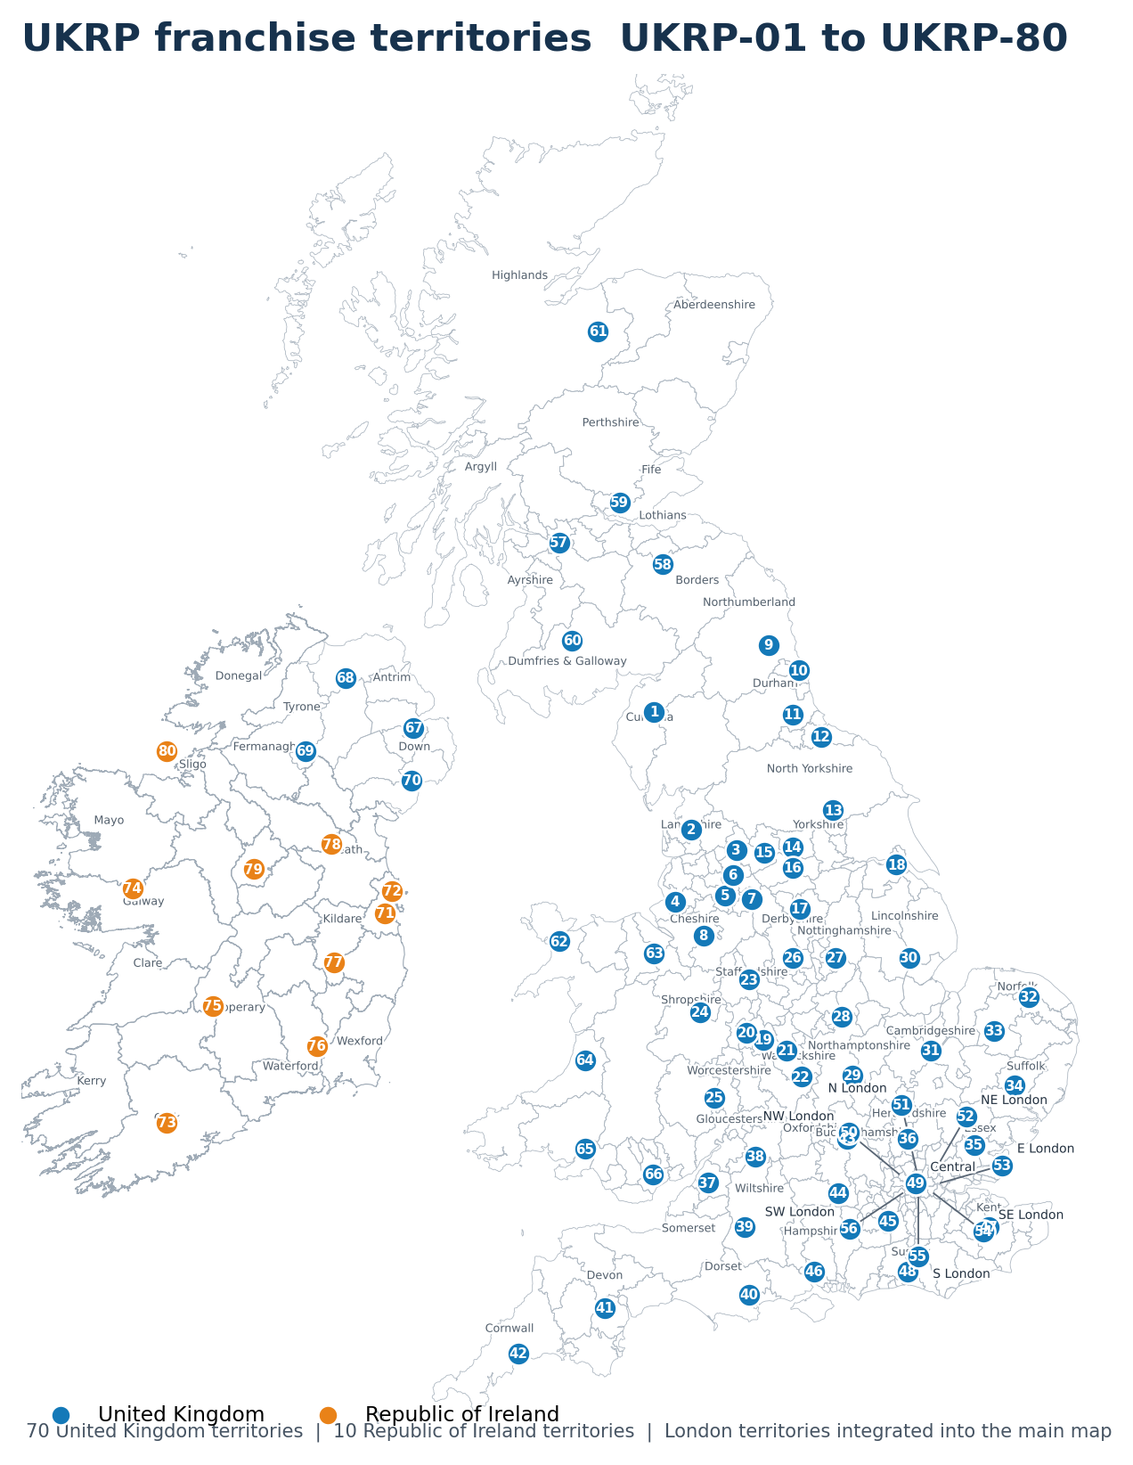
Important status: This map is illustrative and does not define a legally binding franchise territory. The written territory schedule and boundary plan attached to the definitive Franchise Agreement prevail. Local-authority and county lines are included for orientation and must be checked against the boundaries then in force.

